lead management
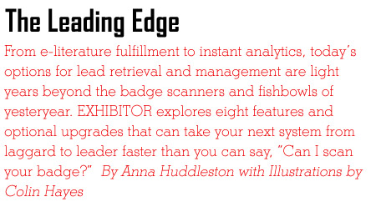 | 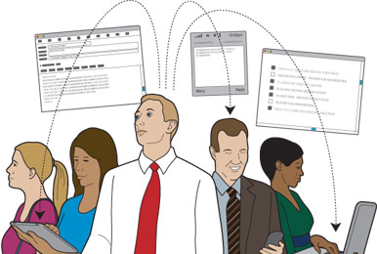

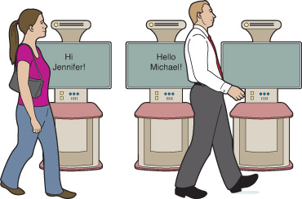

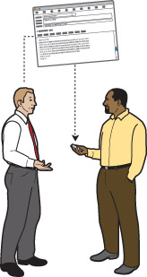
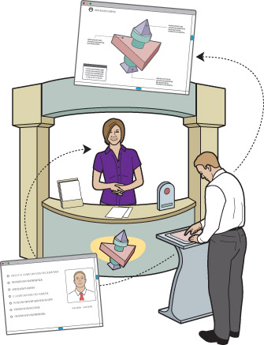
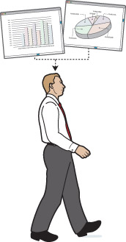
n the business of lead management, it’s all about capturing, qualifying, distributing, and following up. It’s about refining the process and reconciling the data in a way that helps sales reps close sales and exhibit managers benchmark their activity and demonstrate the validity of their programs. Thankfully for exhibit and event professionals, there are myriad options available today with features that make basic badge scanners the rotary telephones of our industry. But with so many options on the market, it can be overwhelming trying to decide which system is right for you. Should I collect leads on my smart phone? Will the system sync with our customer-relationship management (CRM) system? And do I really need all those sophisticated metrics?
Budgets for lead management are finally starting to climb from 1 percent of an exhibitor’s trade show budget to an average of 7 to 9 percent, according to John Hasbrouck, president of NewLeads Inc., a Ventura, CA-based provider of lead-management solutions. That’s a good sign, considering collecting and qualifying sales leads is the primary goal of most exhibit-marketing programs. The uptick might also be an indication that exhibitors are placing a higher value on attendee data than in the past, when a business card in a bowl sufficed as a sales lead.
Today, due to an increasing demand for metrics that justify the cost of exhibiting and data that goes deeper than an attendee’s name, title, and e-mail address, the gap between sales and marketing is narrowing. That narrowing is thanks, at least in part, to advances in lead-retrieval and management options and their ability to integrate with CRM software.
To help you navigate the available options, we’ve compiled an overview of eight new features that can be found in today’s lead-management systems. Once you’ve identified the features you want, you’ll be able to quickly focus in on the kind of system that will provide more streamlined (and more successful) lead management.
Smart Phones
Enhanced mobility is a huge advancement available in many lead-retrieval and management solutions on the market. Using a smart phone as your lead-management device allows you to collect data and navigate the attendee through the booth and your brand experience at the same time, without being tethered to a badge scanner or stationary kiosk during the qualification process, says Siobhan Connellan, senior manager of exhibitor operations at Experient Inc. The company recently introduced an app called Swap, which works on the iPod Touch as well as any data-aware smart phone.
It works like this: The application is free, but exhibitors pay for the activation key that can be used on up to four smart phones. A snapshot of the registration database is then downloaded to the phone so you don’t have to be constantly connected to Wi-Fi to access it. Instead of scanning, you punch a code printed on their badge into the app on your phone. From there, you can verify their contact info, take notes, and record their answers to qualifying questions.
The data is then uploaded to the remote servers of the app’s DecisionPoint portal, which allows you to view your results in real time, including lead count, lead source (i.e., the staffer who captured each lead, as well as each staffer’s lead total), and other data parsed out via an online dashboard in multiple formats. And of course, the whole thing is mobile.
“It used to be that you had to scan attendees’ badges or business cards, but now you can be on the shuttle bus or at a hotel bar and still capture their information,” Connellan says. “It’s a 24/7 operation.”
Near Field Communication
Another driver pushing smart phones to the top of exhibitors’ lead-retrieval wish lists is Near Field Communication. NFC is a “contact-less” information
exchange that’s powered by a card with a chip and a tiny antenna. For the purposes of lead gathering, an attendee’s identifying information can be recorded on a chip, and that data can then be transmitted to exhibitors when they place the chip near an NFC-enabled object, such as a lead-registration reader, product-specific signage, or anything with a sensor. NFC could replace badge scanners altogether. Instead of asking attendees to scan their badge in order to capture their contact info, attendees could volunteer that info by, for example, holding their chip-bearing badges near a display advertising additional follow-up information.
Many cell phones already have NFC capabilities, allowing users to exchange contact details by waving their phones in front of one another. “Soon, most lead management will be phone to phone,” predicts Ivan Lazarev, president of ITN International, a Bethesda, MD-based provider of mobile data-management and information solutions for the trade show industry. So without having to scan a badge — or even have a conversation — an attendee could register for a prize drawing, submit contact info for follow-up, or request additional product information by simply placing his or her NFC-enabled phone near a sensor inside your booth.
iPads and Tablet PCs
Similar to smart phones, iPads and tablet PCs are becoming de rigueur for in-booth and post-show activities, merging lead management with the overall attendee experience. From gathering real-time intelligence and delivering targeted content to building detailed profiles that sync with CRM systems, the possibilities are limitless. The bottom line is that mobility is now one of the most desirable components of lead-management systems, making myriad other features possible.
“An iPad combines lead retrieval and sales tools,” says Roger Lewis, head of marketing for Alliance Tech Inc., an Austin, TX-based event metrics and analytics company that recently launched an iPad solution. Using that solution, you can conduct a basic lead-qualification survey and based on the attendee’s responses, present relevant, customized demos — and simultaneously forward the lead on to the most qualified salesperson. Alliance Tech’s system also updates the registration data as attendees register on site and makes it easy to change survey questions across all devices in preparation for the next trade show.
“Our experience indicates that using iPad-driven technology extends the time attendees spend at the booth and creates opportunities for custom solutions,” says Hasbrouck of NewLeads. The company offers products that run on iPads, including the iPad Lead System, which won a Buyers Choice Award at EXHIBITOR2011. “These devices allow booth staffers to move around and have a wider range of interaction about topics specific to the attendees’ interests.”
Instant Alerts and Analysis
Thanks to the instantaneous-analysis capabilities embedded in some of today’s lead systems, you don’t have to wait until you get home to analyze leads and follow up with hot prospects. When a booth staffer scans an attendee’s badge, many systems can automatically send an e-mail alert to the salesperson assigned to that attendee’s territory, text message senior staffers that a VIP has entered the booth, and even send a “thank you” e-mail to the attendee, with links to additional product information.
“The goal is to create a direct connection between a hot lead on the show floor and the sales force,” says Dean Hills, digital strategist for PRMconnect Inc., a Chicago-based company that specializes in lead capture, e-literature, and measurement. Among other instant-analysis features, the company’s solutions offer “Automatic Sales Rep Mapping,” allowing leads collected in the booth to be categorized based on geographic criteria, and then instantly forwarded to the appropriate reps, regardless of whether those reps are attending the show. By instantly getting the lead from the staffer to the appropriate salesperson, the mapping feature can help exhibitors shorten the sales cycle by striking while the iron’s hot, rather than waiting for the leads to be sent back to the home office, analyzed, input into a CRM database, and distributed to sales reps.
Similar instantaneous-analysis features that can be embedded into the lead-qualifying process can help staffers customize each attendee’s experience in the booth, including selecting appropriate demos and collateral literature. “How well your lead-management solution uses branching logic is likely the biggest differentiator here,” says Charlie Bowden, president of In4Med Corp. of King of Prussia, PA, which specializes in integrating lead management with interactive experiences. It’s called “branching” because as you work through the qualifying questions, each answer determines the next question. This helps you to zero in on the info that interests each attendee and show him or her the right demo or offer the right product.
Because most of the data is processed in real time, your marketing team back at the office or salespeople in the field can follow up and establish contact with the prospect. In the meantime, day-by-day analysis of the activity in your booth gives you hard data to report to your boss and show the potential return on investment from your exhibit-marketing efforts.
E-Literature Fulfillment
Up until 2011, Terex Corp., a manufacturer of telescopic cranes and other equipment, was shipping a dozen boxes of literature to each World of Concrete show that, for the most part, ended up in hotel wastebaskets. So the company sought a lead system that would solve at least two problems: allow for more streamlined retrieval and qualification, and enable staffers to automatically send requested literature electronically.
At the 2011 World of Concrete show in Las Vegas, Terex placed four stationary touchscreen kiosks around its exhibit and supplemented them with five iPads. Each device was loaded with PRMconnect’s lead-management software dubbed Leadature. When booth staff collected and qualified each lead, the system prompted them to ask attendees which, if any, e-literature documents they would like sent to their e-mail account. “At that show alone, we saved over $15,000 in printing and drayage costs previously associated with getting our literature produced and to the show,” says Jennifer Van Dyke, marketing — tradeshows and events, for Southaven, MS-based Terex.
Furthermore, there is little to no chance of human error or staffer laziness resulting in attendees expecting additional information that salespeople ultimately neglect to send.
Just as Terex opted to deliver all of its collateral digitally, many exhibitors are finding that electronic document fulfillment not only saves money and resources; it is also part of creating a custom experience, as attendees get to select only the information that’s of interest to them, and the system instantly e-mails them exactly what they need. Furthermore, some lead-management systems allow salespeople to keep tabs on which e-literature documents each of their leads has read, how many times they’ve read them, and more, helping to customize follow-up calls and direct future conversations toward topics in which each individual has demonstrated interest. Tracking which documents get the highest response also allows exhibit managers to build more effective libraries and even tweak their exhibit programs to more prominently feature topics/ products that appear to appeal most.
Sometimes, the sheer volume of e-literature that an exhibitor can have on hand — without having to print and ship an entire ark full of different brochures for every product it sells — can spark unexpected buying as attendees explore the breadth and depth of the selection. At the Terex booth, for instance, attendees were able to browse various electronic brochures and price lists. “We had several cases where attendees would start browsing through our digital catalogues and then buy equipment they saw electronically but that wasn’t even at the show,” Van Dyke says.
The system also is a helpful tool for booth staffers who may not be intimately familiar with every product, but still need to engage with prospects and be able to answer questions. “It’s a way to craft interaction that creates value, with all materials you need at your fingertips,” Hills says, noting that as exhibitors become more familiar with the technology, they often move from a simple library to integrating a gaming system and creating a complex qualifying matrix for a more granular sales-force delivery. “It’s not a lead-capture system. It’s a full-fledged engagement station,” he says.
Interactive Engagement
Speaking of engagement stations, more and more exhibitors are incorporating games, quizzes, videos, and more into their lead-retrieval devices, all feeding intelligence into their CRM systems while keeping the attendees glued to the screen, soaking in the brand. That’s the basic idea behind interactive engagement, powered by tablet PCs, Microsoft Surface tables, HP slates, etc. As the technology gets more sophisticated and effective, it becomes a two-way street where both exhibitors and attendees learn more about each other. And it’s all based on lead-capture systems, well, lead-capture systems on steroids.
Rich engaging experiences keep attendees in the booth longer, according to Bowden of In4Med, which partners with agencies that deliver interactive content. “Now we can match messaging with each attendee segment,” he says. From microsites populated with video to gesture-triggered interactives, to quizzes and games, the possibilities are only limited by exhibitors’ imagination.
MG Design Associates Inc., a Pleasant Prairie, WI-based exhibit company, utilized an interactive-engagement approach to create a Mansion of Mystery experience inside its booth at EXHIBITOR2011. The lead-management system provided a foundation for a customized “journey” that felt more like a game than a qualifying conversation, but both gathered and showed actionable data through the process. Upon entering the booth, attendees scanned their badges and answered a series of questions that identified their “hot buttons” and paired them with one of five personas (the colonel, professor, actress, socialite or heiress) based on the challenges they faced in their trade show programs. As they moved from station to station, each of which showcased MG Design capabilities and technologies, they received targeted information tailored to their specific persona.
For example, if they identified with an actress, that meant that they were particularly concerned about the aesthetic and design of their exhibit and most of the presentations they saw focused on design capabilities and projects from MG Design’s portfolio that looked as stunning as a movie star. At the end of the day, MG Design had a database not just with names of prospects, but with topics that concerned each individual attendee, allowing salespeople to customize their follow-up to address those particular issues.
Compliance Features
Many exhibitors, particularly in the pharmaceutical and life-sciences industries, face the challenge of staying compliant with federal and state regulations. The Sunshine Act and state regulatory compliance mandates that companies report any transfers of value to health-care professionals. Some lead-capture systems can help you keep track of that. “We can identify health-care professionals by their national provider number and control premium distribution to one customer,” says Bowden of In4Med. Such lead systems can also generate reports that list exchanges in total or state by state.
The Food and Drug Administration has specific guidelines about showing promotional information to U.S. and international health-care professionals. Attendee segmentation and transaction tracking through a lead-management system can help mitigate some of those issues. To help you stay compliant, attendees can be segmented by geographic region and shown only content that’s approved for them. “We can show international visitors general company information instead of product-specific content,” Bowden says. “Exhibitors could also use the system to automatically show country-specific information to international visitors, such as showing a German physician the German-approved materials in German.”
Measurement and Analytics
From quick snapshots to layering and cross-referencing data for a comprehensive picture that spans several trade shows, new lead-management systems offer a plethora of metrics and measurements that ultimately deliver what most marketers consider the Holy Grail — analytics they can use to prove and enhance their program’s value.
“Most exhibitors want the reporting rolled into dashboards,” says Hills of PRMconnect, referring to visual representations of key indicators through pie charts and graphs of the number of leads, pieces of literature sent out, top-performing booth staffers, etc. They are looking to answer questions
such as “How many unique new leads did we get?” and “What demo was the most effective?” Yet some are looking to take full advantage of the technology and also track the attendee’s journey around the exhibit, the amount of time attendees spent at each station, the pieces of literature requested, and even the amount of time it took a visitor to open his or her follow-up e-mail.
Integration with the exhibitor’s CRM system or some other type of agreed-upon reporting is crucial to making the most out of this technology. Many exhibitors choose to select their own lead-management providers instead of going with the systems offered by show management because they want uniform reporting across their entire trade show program. With many systems, the data is collected in real time and is accessible remotely from the company’s headquarters or by sales reps in the field, and it’s presented in a uniform format that they are used to viewing, rather than a show- or provider-specific format with which they may not be familiar.
Is it possible to have too much information? Hasbrouck of NewLeads says that information overload is an issue with a lot of clients as they look for actionable data they don’t have to decipher. “What it comes down to is simplicity and strategic gathering of information,” he says. “You’ve got to determine what strategic elements and info you need to gather to make the data relevant to the salespeople and to connect the dots for them.”
No matter which lead-capture and management system you decide to use in your company’s exhibits, experts agree that the booth staff needs to be comfortable using it and that the company has to have a strategic plan and resources in place for getting the return on the investment. As Lazarev of ITN puts it, “It’s not just the capturing. It’s what you do with the data that makes the difference.” E

http://www.exhibitoronline.com/exhibitormagazine/july11/lead-management-the-leading-edge.asp?email=wbnixon@aol.com&s=1836Cbb

